Dear Purnima,

Are you back in Geneva again ? I hope you had a wonderful time in London.
See anyone or anything totally fascinating ?

I agree that the male dominated societies in which we live insist on making
choices for "their" women, choices that they have little or no understanding
about, and choices that tend to keep women under the yoke of servitude to
male desire. And one of the things that most worries me is the
used-to-be-called "moral majority", although they now exist under the guise
of the Tea Party, and their avowed determination to overturn Rowe vs Wade.

One of my all-time favorite French feminists, Gisèle Halimi, was a
Tunesian-born lawyer who was very instrumental in finally getting the French
government to legalize abortions. She took on the case of six women who had
openly admitted to having had an abortion as a challenge to the French law
against them. The trial took place in the city of Bobigny, just north of
Paris, and after a series of frustrations because of legal manipulations on
the part of the court, Halimi finally won the case, which became a watershed
decision that set precedent for the eventual legalization of abortions in
France.

By the way, there is a very powerful film, "Une Affaire de femmes" with
Isabelle Huppert who plays the role of a woman who performs abortions in
order to make enough money to survive and raise her son. It's a true story,
and she was arrested and executed (long live the guillotine ! ! !) by the
French government as an example to other women. Can you imagine ?

http://www.imdb.com/title/tt0096336/

With Bush II stacking the supreme court with conservative justices, I'm
really afraid that Rowe vs Wade's days are numbered.

What is your schedule next week ? Your Geneva days are coming to an
all-too-rapid end. We at least need to have a long chat over lunch.

Hope to see you very soon. Giant hugs,

Roger

———————————

Dear Roger

Still in London and surfing between meals... Guess what flashed
across my screen, a must watch update on the latest on the Pro-Life vs
Pro-Choice debate chk it out below:

http://wn.com/GOP_focus_on_eroding_abortion_rights__The_Rachel_Maddow_Show_May_26th,_2011

Tell me Roger, do you really believe having an abortion is a choice
for women..."hmm what should i do today a manicure a pedicure or swing
by the local planned parenthood and have an abortion?"

Absolutely not!!! There is no question of choice but a compulsion, a
desperate act based on the physical fact of being born female. There
is no Pro-Life vs Pro-Choice debate as a woman is not left that
choice.

What do you feel?

Hugs
Purnima

————————————

Jack and Jill (Captain Jack and Gilles)

Dear Roger,

My introduction to French cinema at this late stage has been a thunderbolt out of the blue, jolting me out of my current sleepy/un petit peu bored state into this new and fantastic realm of relatable humour. I'm a fan.

I have just forwarded you the video clips (which I made) commenting on the movies recommended : Le Diner Pour Le Cons, Le Nom des Gens, Le Rue de Plaisir (to be watched) and my favorite Rien a Declarer which is a "must see", chk it out below:

https://youtu.be/Tz0Z1IYg8i8

Would love your feedback and recommendations!

Much more in the pipeline...

Purnima

———————————————

6/13/11

GENEVA BLOCKBUSTER

Dear Roger,

No response from you regarding my nascent attempts at movie making. Yes, it looks like I'm morphing into your "Woody" and would greatly appreciate your feedback on the forwarded impromptu clips taken with my iPhone.

Well, much to tell as the story of Jack and Jill(Gilles) continues. Yes, I know how this one will end, but isn't it all in the journey? I wish you were there when I first asked him his named (after he spent six months flirting /winking at me from behind the video library counter)..."It's Jill". "What", I responded, and he repeated Jill. I finally pinned him down and invited him to engage in dumb charades..."So what does it sound like/ Rhyme with?", and then I got it. He was saying Gilles, Gilles, Gilles which sounds like Jill, Jill, Jill. That's because the French "G" sounds like "J" and the "J" sounds like "G"! I then leaned forward and introduced myself "You can call me Jack, Captain Jack".

Contrary to the opinion of the misogynistic Mr. Naipaul, most female writers are not full of fluff. And most importantly, as the editor of the IHT correctly highlighted "the confusion/ contradiction" in his succinct piece on Naipaul's attitude towards female writers mirroring my view that as you delve into a story, you are essentially delving into fantasy, an alternate reality, where your environment, time and space are altered, neither do you exist (as a male) and neither does the writer(as a female), but merely the story where you might find yourself playing (empathizing) with the male role or the female one which does not change your gender and neither does it modify the gender of the author. I think it's time for him to retire... what do you think?

Do check me out with Jill(Gilles) the guy behind the counter at our local Blockbuster (Video Club) making a strong case for "Real Life", otherwise how would one ever meet Jill!

See below my first attempt at movie making (a movie credited to my tech savvy pre-teens who taught me iMovie and helped to merge sound and video):

https://www.dropbox.com/s/zpdagthrqsa21h3/700%20copy%202.mp4?dl=0

I then realized that this above clip (however thrilled I was with it) was insufficient to fully reflect my state of mind/expression, it did not say the words of my favorite Hindi love song/ ghazal:

So, I have pasted below an old Bollywood favorite Hindustani ghazal with Nutan playing the lead female role. Growing up I was often told I had a striking resemblance to this actress Nutan, do you see me this Indian actress of yesteryear from Bollywood of the 1950’s and 1960’s?

Do check me out below in an old b/w Bollywood movie from 1963- Nigahein Milane Ko Ji Chahata Hai:

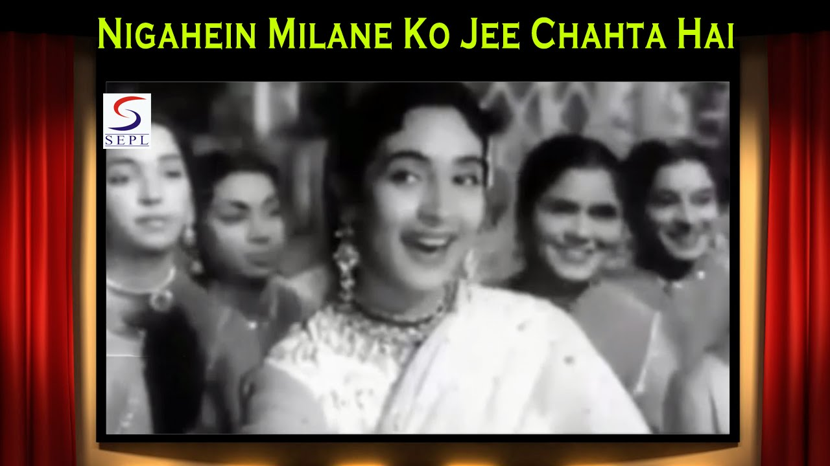
The lyrics voice my clip pasted above:
My soul (Ji) desires the exchange/ meeting (Milana) of glances (Nigah)

http://thebollywoodfan.blogspot.com/2008/04/asha-bhosle-week-nutan-in-nigahein.html

A ghazal is a song, a piece of poetry from my part of the universe spread by the Sufi mystic poets (a long mail pending on the Sufi mystics...Sherazade has a few more nights). The Persian poets like Rumi, Iqbal and Galib, their words and ideas have filtered down into the vernacular languages creating a magical mesh of verse, sound and music which forms an integral part of our culture. A Ghazal is best described by Wikipedia as:

The ghazal (Arabic/Bengali/Pashto/Persian/Urdu: غزل; Turkish: gazel) is a poetic form consisting of rhyming couplets and a refrain, with each line sharing the same meter. A ghazal may be understood as a poetic expression of both the pain of loss or separation and the beauty of love in spite of that pain.

Roger, I would like to share words of the above pasted ghazal with my definitions supported by the definitions(from the University of Chicago Library of South Asian Languages) pasted below:

It is a secret (Raz) matter
Unsure if I should speak of it in the open court (Mehfil) or not

My soul (Ji) desires the exchange/ meeting (Milana) of glances (Nigah)
My soul desire the relinquishment/ permitting to be taken (Lutna) of heart and life

The allegation/aspersion(Tohmat) that the world calls love (Ishq)
My soul desires to accept that allegation

nigāh Nigahein (Plural)

P نگاه nigāh [Zend ni+kaśa, rt. kaś; S. निकाश, rt. काश् with ni], s.f. Look, glance, sight, view, regard; consideration;—look, aspect (of);—watching, observation, attention;—custody,
milānā, v.n. To pair (as birds), milānā (-se), To unite in feeling
Ishq
عشق ʻishq inf. n. of عشق 'to love passionately'
A عشق ʻishq (inf. n. of عشق 'to love passionately'), s.m. Love, excessive love, passion (for,-kā)

Raz
راز rāz [Pehl. rāj; Zend razaṅh, rt. raz; S. रहस्, rt. रह्], s.m. A secret, mystery:—rāz-posh, s.m. One who keeps or conceals a secret:—rāz-poshī, s.f. Keeping or concealing secrets:

Mehfil
محفل maḥfil n. of place fr. حفل 'to collect, come together,' c.
A محفل maḥfil (n. of place fr. حفل 'to collect, come together,' &c.), s.f. A place of assembling or congregating; time of meeting or assembling; a sitting-place, an apartment;—an

تہمت tǒhmat for A. تہمة
P تہمت tǒhmat (for A. تہمة), s.f. Evil opinion; suspicion (of guilt); allegation; false accusation, falsely charging one with a crime, aspersion, detraction, calumny, slander:—tǒhmat denā, tǒhmat
Anxiously waiting as time closes in...

do write

Love

—————————————————-

6/13/11

Dear Purnima,

What a funny take on Jill/Gilles, and now I understand your earlier references to Jill. Just so you're not tumbling too far down the hill, but if you land in a cool little "arts et essai" cinema showing French classics...

I'm thrilled that you have (finally) discovered French cinema, but I'm a little worried about your choice of favorites. Danny Boon and his admittedly really funny films are terribly popular with the French (and Belgian) public, but he doesn't quite carry the intellectual baggage that made French films the envy of Hollywood for many years. Try some Alain Resnais, Goddard (Breathless - A bout de souffle), Chabrol (Le boucher), Agnès Varda (Sans toit, ni loi), Truffaut, even Beineix (Diva is a great film). Another film you might enjoy is Le fabuleux destin d'Amélie Poulain.

Speaking of films. the new Woody Allan, Minuit a Paris, is excellent and the new Iranian film, Une Séparation, playing at the Rialto, is superbe - the consequences of a divorce in an Iranian family (you could relate to the theme !)

Unfortunately, I wasn't able to savour your film making talents. As usual, none of the links to Flickr worked for me. I always get the message that I don't have authority to access the pages. Can you show it to me tomorrow over lunch on your iphone/ipad ?

Yes, indeed, Naipaul should definitely withdraw from the public scene. I don't know why old farts like him who have achieved a certain measure of public acclaim because of a Nobel Prize have to spout off about topics they really know nothing about like the superiority of masculine writers. Putting down the likes of Jane Austin is like Gerard Depardieu, an icon of French films for some 30 years, saying that the actress Juliette Binoche is a looser and has no talent. In my opinion, Binoche is one of THE great French actresses currently on screen, and Depardieu should be retired. If you ever get a chance to catch Binoche together with the mesmerizing (he has fantastic eyes) Daniel Day Lewis in the film adaptation of The Unbearable Lightness of Being, don't you dare pass it up. It is a beautiful, haunting film. I could picture you playing the role of the other female character in the film, Sabine ! And then there is always the exquisite The English Patient

And, my dear, you are far more beautiful and enchanting than the Nigahein in the clip you attached.

Where shall we meet for lunch tomorrow ? 1:00 is fine.

And can you come for dinner here on Weds. the 29th ?

Love and hugs,

Roger,

P.S. I'm already feeling teary eyed at the thought of your leaving Geneva !

———————————————-

6/14/11

Dear Roger,

Thank you for this wonderful long list of French movies to watch, I just wish I had this list earlier before my 1001 nights were coming to a close (truly, it's almost been 1001 nights in Geneva!).

Well, this is a list I plan to take with me where ever I land, and hope I am still linked with you through cyberspace. it would be fun to watch some films together.

I'm looking forward to our lunch tomorrow at 1pm, shall we meet at my place and then walk downtown?

love and hugs,

See you tomorrow.

Purnima

